**1.: Executive Summary**

The Stacionárius Pont team is responsible for developing an application that makes a pizza shop every day’s easier and smoother. The tasks of the application include the registration and management of orders and customers, and the preparation of statistics according to the customer's requirements. Because they provide services so it's understandable, the customer does not want to lag behind their competitors. The business is dynamically growing, so it is expected that there will be additional demands after the application is delivered. Considering expectations and tasks to be implemented, we intend to implement the project using HTML, CSS and JavaScript technologies.

**2.: Description of the current situation**

### At the pizzeria, orders are written down on a tiny sheet and they try to get them to the kitchen where they see what kind of pizza they need to make. This method is rather slow, due to human error, there have been misunderstandings about the product being ordered, this is one of the reasons why need for the application. The customer knows that rivals have recently invested in a similar application. This has resulted in a spectacular boom in sales, smoother business processes and less misunderstanding. At the moment, pizzerias do not store any traffic or consumer data, cannot compile statistics on their most popular and unpopular products, and they cannot give loyal customer promotions because they do not know their customers. The menu is currently only available on the menu, which the customer sees when they go into the pizzeria, leaflets are sent out every 1-2 months showing the current selection. The statistics, the determination of salaries, are made by humans on paper, which has the problem that it is slow enough and has an opportunity to make mistake. The couriers had misunderstanding too because of the old paper system, they took the wrong pizza to the given address, the person who take the order has an ugly hand writing because of this the courier have to come back to reconciled. In the kitchen, the "chefs" cannot fully to keep track of for the ingredients, so it has happened that in the middle of fulfilling an order, there was no ingredient, and then, in the middle of making pizza, they had to obtain the product quickly.

**3.: Desire dream system**

After several interviews, we were able to get to know the customer and his needs. The software which is under create is designed to make easier the everyday in the pizzeria. Hopefully, the development will be able to meet the customer all needs with the help of the IT capabilities of the era. In addition, we support our future development by designing our software so that future development can be seamless.

The Customer currently has two pizzerias within the city of Eger. As the business continues to grow, it can expect to open new restaurants with these, new services. This is the first and foremost requirement of the software, so that not only individual restaurants can be managed, but it can manage other restaurants in other cities, within the program.

In addition, you need a system where you can track the number of orders, material costs, and other costs involved, including all cash moves. Web traffic is also need in line with increased traffic and age trends. In addition to telephone ordering, our recommendation is to operate a website through which customers can not only order but also register. That way, they can signal their commitment to the pizzeria. Customers enter the pizzeria shopper's by giving name, phone number, home address, or shipping address. Also, if you are already registered but want to order by phone, you can also identify by phone number without having to re-dictate all your details. Of course, it is possible to modify them at any time. You also have the option to view order history, when, what you ordered, and for what amount. In our experience so far, it would greatly increase customer satisfaction that they could also be informed about the processing of the food and drinks ordered. In addition, if a food cannot be prepared for any reason, it cannot be ordered online.

The supply is tailored to trends, which is why it is important to keep track of orders and make statistics. With this they can respond to market behavior. During the discussions, it turned out that it was the job of the chef to set up the menu, so he gets the requirement permission for this.

There was a special request for in recognition of loyal customers, if somebody place orders in month, and if the orders amount higher than a predetermined amount (in this case, 10 thousand HUF), then he can order at the next month with a discount (10% in this case).Of course, these values can be changed at any time by the store manager. (Multiple authorization levels are required in the internal administration system. The chef or material purchaser cannot see the salaries, expenses, revenues, etc.)

There are a few requests with the financials. Due to the high tourist turnover, payment in euros and forints is possible, however, at delivery only payment in forints is possible. In the case that they are not consumed locally, they can also pay by bank card. This must be indicated at the time of ordering.

The new system also needs to be prepared for statistics to support the success of the business. In addition to aggregating expenses and revenues, you should also be able to create pdf documents on a daily, monthly, and yearly basis. Of course, they should be done completely anonymously. Communicating with other parts of the business is at least as important as they are an integral part of the business.HR staff should also be notified of monthly cash flow.

**4.: Connecting competitions, laws, decrees, rules and standards.**

* 2016. year XCIII. Act on Collective Management of Copyright and Related Rights
* 1997. year CLV. Consumer Protection Act
* 1999. year LXXVI. Copyright Act

210/2009. (IX. 29.) Government Decree on the conditions for engaging in commercial activities REGULATION (EU) No 1169/2011 OF THE EUROPEAN PARLIAMENT AND OF THE COUNCIL (25th of October 2011) With respect to the processing of personal data by natural persons and the free movement of such data; and Regulation (EC) No 95/46 (General Data Protection Regulation). THE EUROPEAN PARLIAMENT AND THE COUNCIL REGULATION (EU) 2016/679 of 27th of April 2016.

– CXII of 2011 Law - Freedom of Information Self-determination and Freedom of Information (hereinafter referred to as "Infotv.")

– CVIII of 2001 Law - Electronic Commerce Services and the

on certain aspects of information society services (in particular Section 13 / A)

– XLVII of 2008 - Unfair commercial practices against consumers prohibition;

– XLVIII of 2008 Law - Basic Conditions of Economic Advertising and Certain

(particularly Article 6)

– XC of 2005 Law on Freedom of Electronic Information

– Act C of 2003 on Electronic Communications (specifically §155)

– 16/2011. s. Opinion on Best Practices for Behavioral Online Advertising EASA / IAB recommendation

**5.: Current business process model:**

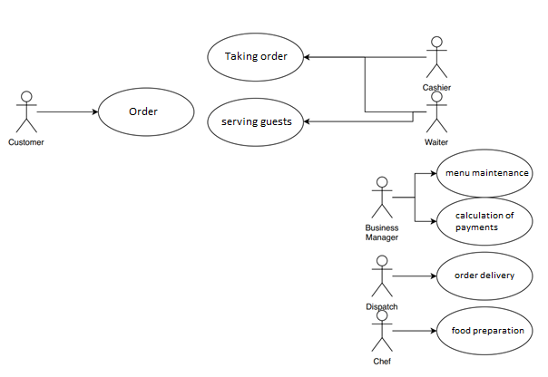

The whole system is currently paper based. If someone would like to order from the pizzeria, you can do so only by phone and you can get information from the assortment there, or if you have a flyer at home. As a result, the customer does not even know if the company has the food in question, only by calling the restaurant and asking. The chefs have no systematic work, they cannot keep track of what they are running out of. It is not possible at this time to keep statistics on their best or least consumed foods.

They cannot keep track of their customers, so they can't give them loyalty discounts. The waiter in the restaurant picks up the order, writes it down on a piece of paper and delivers it to the kitchen. Payments are also determined on paper. Couriers are given paper addresses on where to go and what to deliver, which has been a mess before.

**6.: Model of required business processes:**

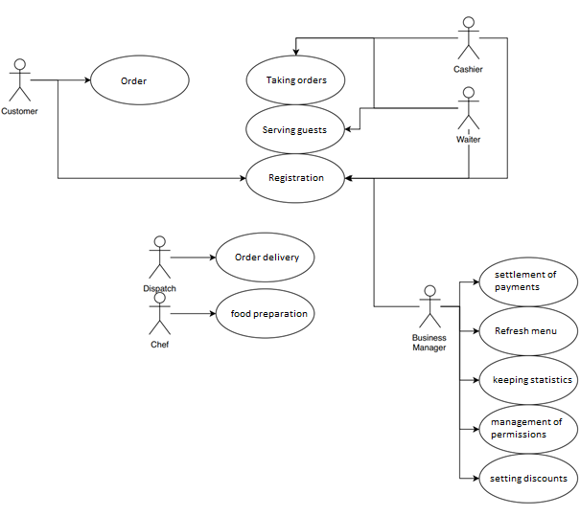

On the homepage of the site, it can be chosen if a user

or an employee would like to enter the system. (This is always the subject of the registration.)

User must provide:

* Name
* Address
* Phone number

Guests can order home via the website. They choose from the food available, what they want to order, to what address, when and how to pay (by credit card or cash - in forints).

So that guests have their own account, you can keep track of them

(Those who order at least 10000HUF will receive a 10% discount on the following month.) The restaurant could place orders online, which would improve wait times. Choose from the available meals what you would like to order and how you want to pay (euro-forint-credit card).

You can keep track of the food and its ingredients on the employee interface.

Statistics can be kept on what foods consumers consume; how much they spend at the pizzeria.

You can keep track of which employee worked for a given month,

then calculate your salary based on that.

Daily / yearly statistics, reports in the Admin interface.

.

**7.: Requirements list**

|  |  |  |  |
| --- | --- | --- | --- |
| *Requirement number* | *Requirement name* | *Requirement for more details* | *Exposition* |
| R001 | Data to be stored | Chapter 3, Chapter 6 | What data we want to store, including data protection considerations. |
| R002 | Indication of payment methods | Chapter 3, Chapter 6 | Display each payment method and its terms. |
| R003 | Electronic menu | Chapter 3 | The current menu, will be available online. |
| R004 | Creating statistics | Chapter 3 | Creating / generating various statistics and statements within the program. |
| R005 | Anonymous Statistics | Chapter 3, Chapter 4 | The statistics that you produce should be anonymous. |
| R006 | Order records | Chapter 3 | Through the application, the admin can see the current orders through the admin interface. |
| R007 | Similar Offers Based on Order | Chapter 3, Chapter 6 | A registered guest, after ordering, get products similar to their previous orders. |
| R008 | Discount for a certain amount | Chapter 3, Chapter 6 | If a guest purchases more than X in a month, they will receive orders at X percent the following month. |
| R009 | Roles | Chapter 3 | The app will be used by more people, not everyone will be able to view everything, it requires roles. |

Data’s that are required to store: Name, Address, Phone number + recognition of the number.

Make it clear that you can pay with EUR in the restaurant but only with HUF in case of delivery

or credit card if it's indicated during the order. Also make new ways to pay.

On the website there has to be a food menu which is updateable

and it has to alert the store if something is running out or completely out of stock.

It has to be able to make statistics about the orders and the food that's been bought in the restaurant.

Track the monthly payout and income and make these printable.

Make a yearly statistic the same way and a daily statistic which is available on the admin panel.

(The statistics has to be anonym!)

Register the orders of the users also show ads to the users based on their orders.

After 10 thousand HUF spent in a month the user gets a 10% discount for the next month.

Permissions: Owner: Full access, changing the data on the website, modify the status of the workers.

Admin: Access only to the data on the website.

**8.: Dictionary of definitions**

*HTML:* Hypertext Markup Language, a standardized system for tagging text files to achieve font, color, graphic, and hyperlink effects on World Wide Web pages.

*CSS:* *CSS:* Cascading Style Sheets (CSS) is a style sheet language used for describing the presentation of a document written in a markup language like HTML. CSS is a cornerstone technology of the World Wide Web, alongside HTML and JavaScript.

*Java Script:* often abbreviated as JS, is a high-level, interpreted scripting language that conforms to the ECMAScript specification. JavaScript has curly-bracket syntax, dynamic typing, prototype-based object-orientation, and first-class functions.

*Roles:* Roles are created so that users do not have to be given different privileges individually, but by simply assigning their roles will give them the privileges assigned to the role. In addition, roles can easily and quickly change the access permissions required for different user groups.